

Alexandria University

Faculty of Engineering

Electronics and Communication Department



Ahmed SamehTaha 21010083

Amir Mohamed Kasseb 21010302

`

**Signals & Systems**

Lab (2) Report

**By**

**Supervised by:**

Eng. Ahmed Mostafa

Eng. Esraa Ragab

Exercise (1)

**Procedures**

* The signal required from -2 to 3, and the sample rate is 100 Hz.
* This signal consists of a DC segment equals to 4 (y1) from -2 to 0 seconds, and another DC segment equals to 3 (y3) from 1 to 3 seconds.
* A quarter cycle of a sinusoidal wave (y2) from 0 to 1 seconds, with amplitude 1 from 3 to 4.
* Concatenate the 3 segments in y
* The segment was plotted and the limits of graph was adjusted by the instruction:

axis([xmin, xmax, ymin, ymax])

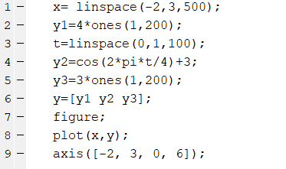**The Code**

**The Output**

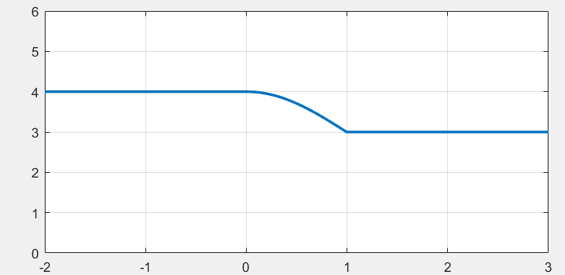

Exercise (2)

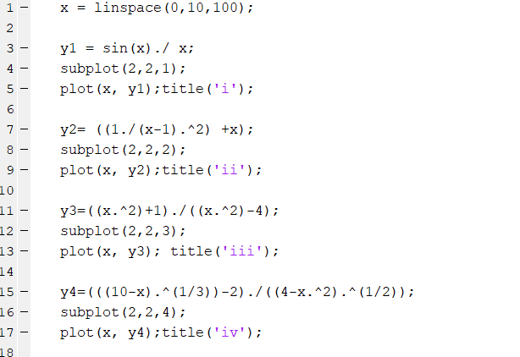**The Code**

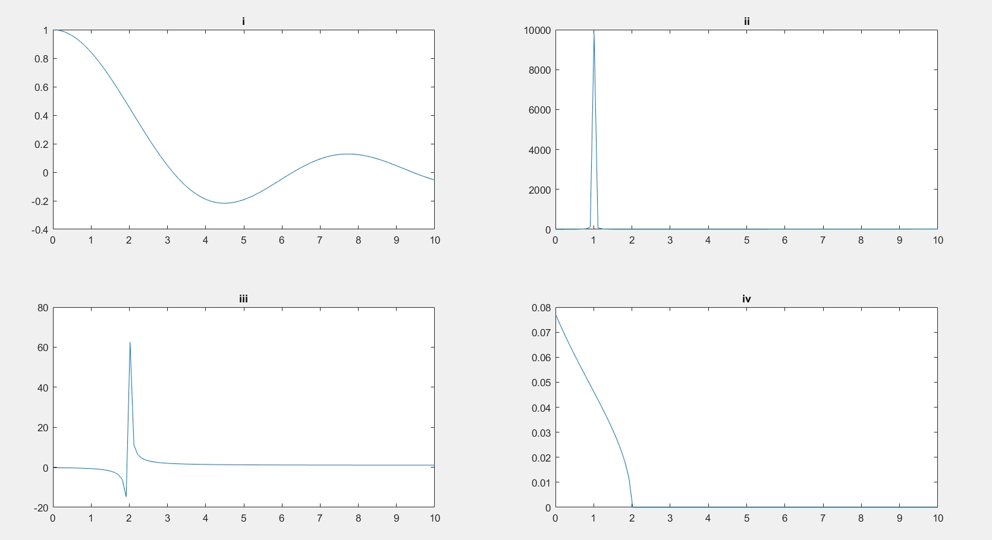**The Output**

Exercise (3)

**Part (i)**

**Procedures**

* t=n*Ts = n*(1/Fs)
* 𝑥𝑎(𝑡) = sin(2𝜋𝐹𝑜𝑡)
* Plot the discrete signal 4 times by changing 𝐹𝑜 with values: 0.5,2,3 and 4.5𝐾Hz

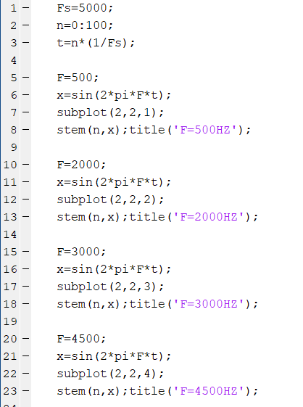**The Code**

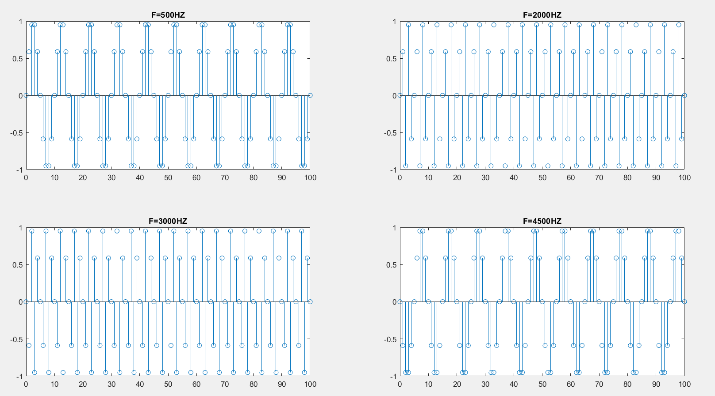**The Output**

**Part (ii)**

**The Code**

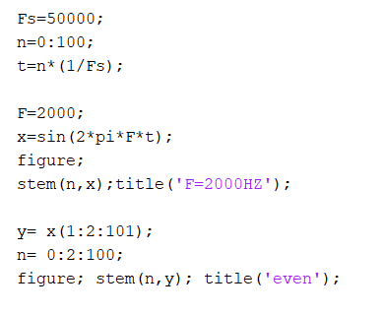

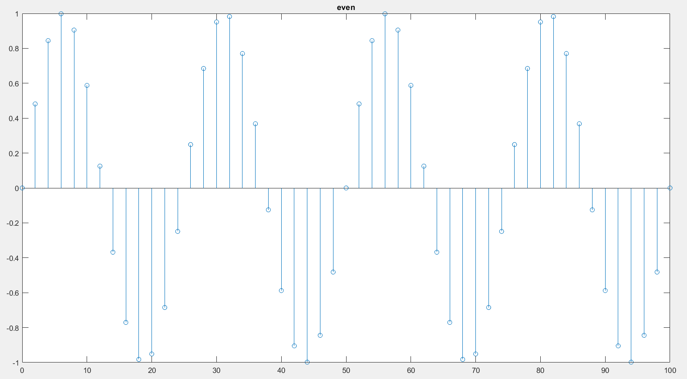**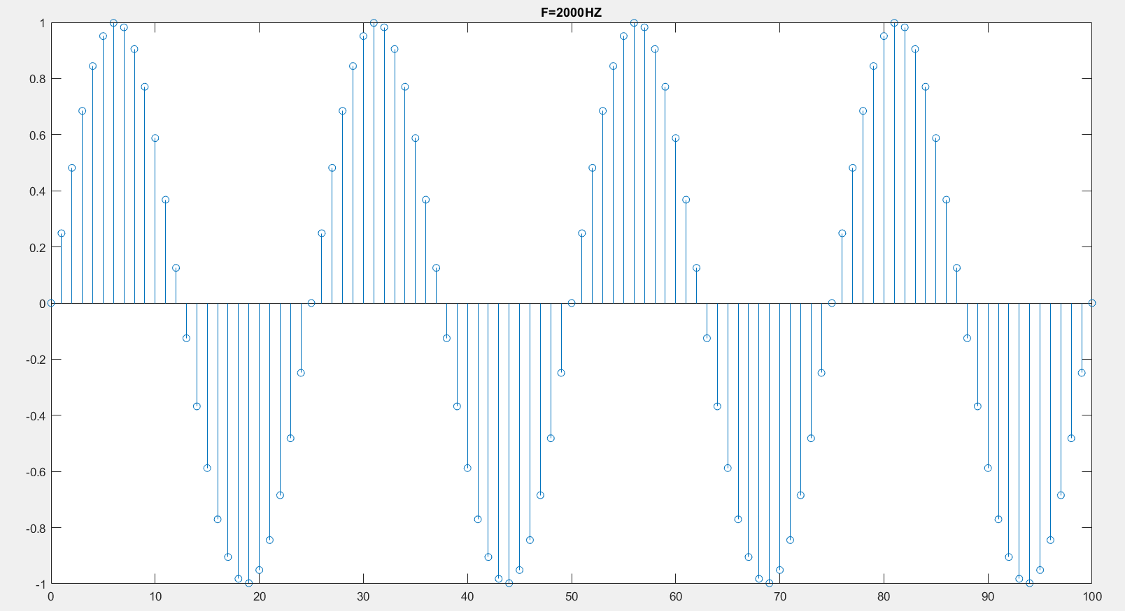The Output**

**Comment**

The frequency 𝑓𝑜 of the signal 𝑥[𝑛] = 1/25 Hz.

𝑦[𝑛] is periodic with frequency 𝑓𝑜 of the signal 𝑥[𝑛] = 1/25 Hz.

Exercise (4)

**Part (i)**

**Procedures**

* 𝑇 = 2 𝑠
* t=n*T and |𝑡| < 40 s. so, -20 < n < 20
* Plot the discrete signals x and y
* Plot the corresponding continuous-time sinusoid from which the samples are taken

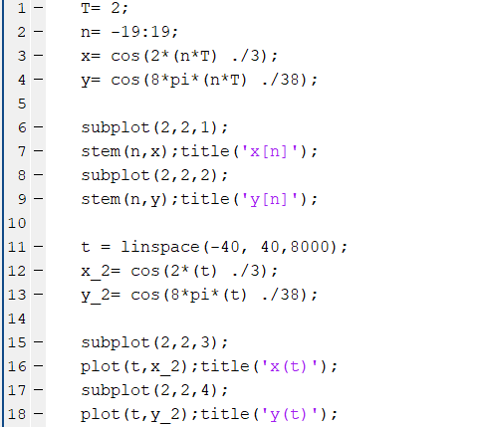

**The Output**

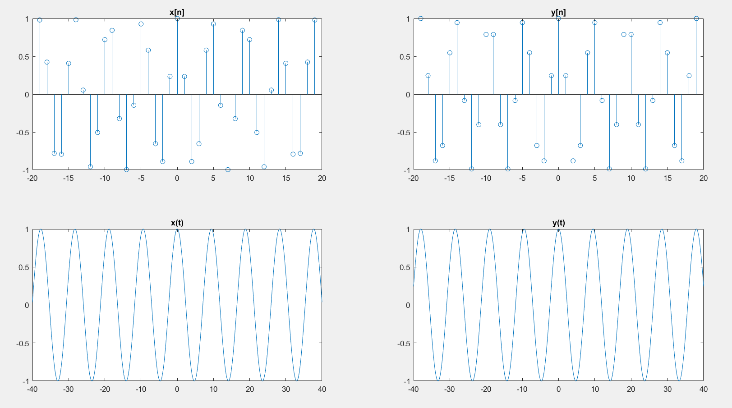

**Comment**

As shown in output, x(n) is not periodic, but y(n) is periodic and its period = 19 s.

Number of cycles of the continuous time signal in one period = 2 cycles.